Akash Chaurasia

JHU CS461 Fall 2019

Homework 2

**Parameters for methods:**

detect_corners:

* w_diam: the diameter of the square window used to construct the H matrix (second moment matrix). This parameter defines the scope of corner detection (large scale vs. small scale corners).
* k: coefficient of the (trace)2, used to calculate the R value at each pixel. This affects the R-values and thus how likely a pixel is to be identified as a corner.
* s_size: the size of the sobel filter used to calculate the gradients of the image. This defines the size of edges that are detected.
* r_thresh: the threshold for R-values to be considered a strong corner, multiplied by the max value of all R-values to determine the final threshold. This affects the required ‘cornerness’ of a pixel for it to be identified as a true corner. Tuning this essentially increases/decreases the number of corners detected.
* nms_window: the size of the window used for non-max suppression. This affects how far apart two corners must be to be detected as corners.

match_corners:

* wsize: size of patches from each corner to extract, where patches are used to match corners. A larger patch size results in more accurate matches between two corners.

compute_affine_xform:

* p: desired probability of at least one of the N trials of RANSAC having no outliers
* e: approximated proportion of outliers in given data
* s: number of data points to randomly take in each sample
* inlier_thresh: max Euclidian distance between a transformed point and the true match for the pair of points to be considered an inlier

**BIKES**

Optimized parameters:

|  |  |
| --- | --- |
| **Parameter** | **Value** |
| w_diam | 7 |
| k | 0.05 |
| s_size | 3 |
| r_thresh | 0.01 |
| nms_window | 7 |
| wsize | 9 |
| p | 0.999 |
| e | 0.5 |
| s | 3 |
| inlier_thresh | 20 |

bikes1 🡪 bikes2

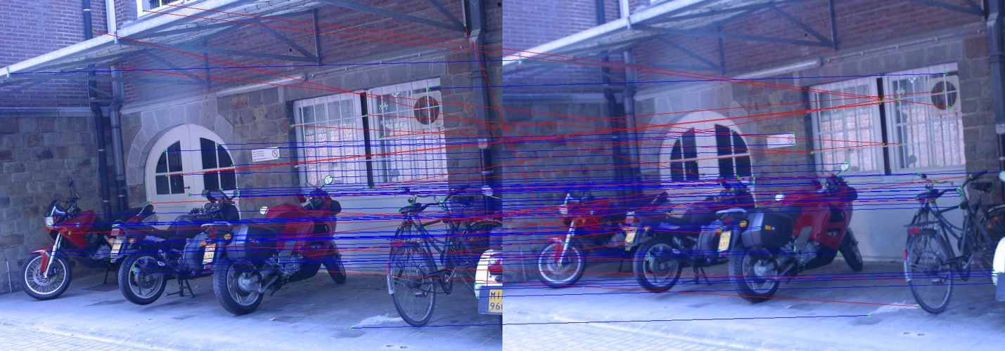

*Results of RANSAC: outliers (red) and inliers (blue) with the optimal affine transform*

Calculated affine transformation matrix:

[[ 1.0090e+00 -1.0000e-03 2.2330e+01]

[-2.0000e-03 1.0000e+00 -2.5082e+01]

[ 0.0000e+00 0.0000e+00 1.0000e+00]]

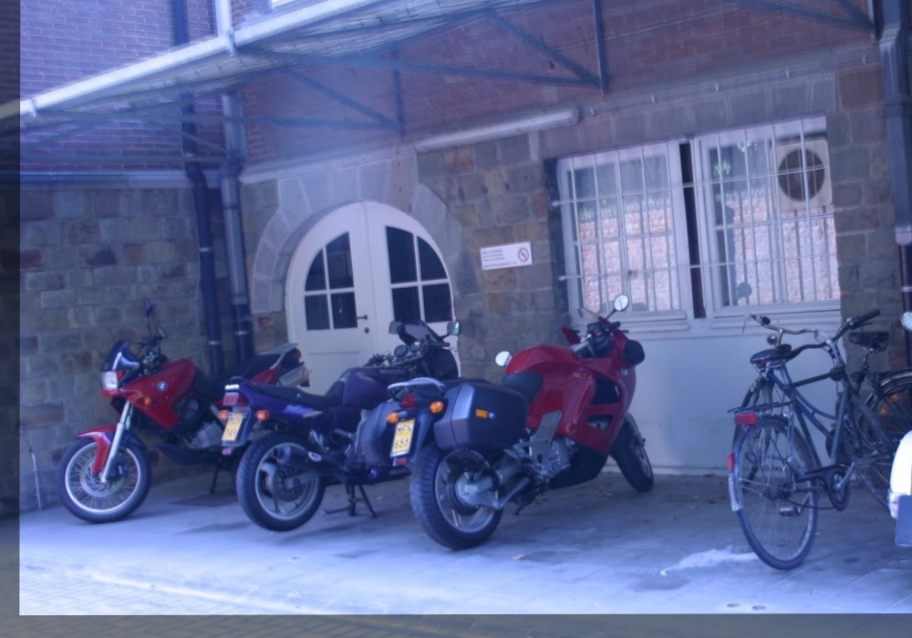

*Results of image stitching using the calculated transform*

**Discussion:** This alignment worked very well. At the borders of the two overlaid images, it is clear that artifacts, such as the curb, roof, and bricks in the wall on the left all line up between both images. There is very little visible blurring or discrepancy in overlaid objects.

bikes1 🡪 bikes3

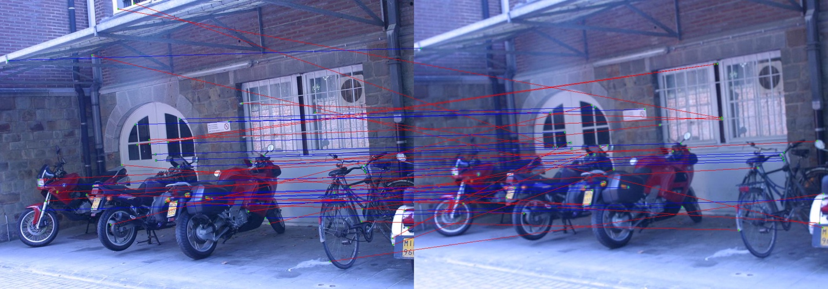

*Results of RANSAC: outliers (red) and inliers (blue) with the optimal affine transform*

Calculated affine transform matrix:

[[ 1.0120e+00 -1.0000e-03 -1.0260e+00]

[-2.0000e-03 1.0120e+00 -3.1616e+01]

[ 0.0000e+00 0.0000e+00 1.0000e+00]]

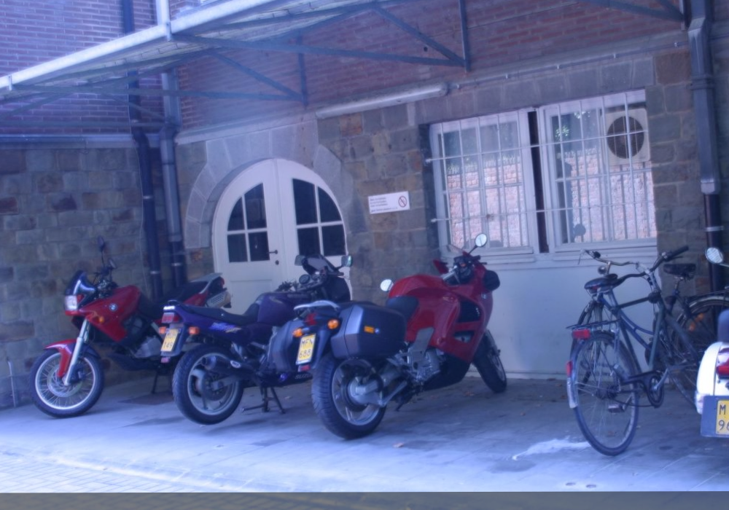

*Results of image stitching using the calculated transform*

**Discussion:** This alignment worked very well, possibly better than the bike1 and bike2 alignment. At the borders of the two overlaid images, it is clear that artifacts, such as the curb, roof, and bricks in the wall on the left all line up between both images. There is very little visible blurring or discrepancy in overlaid objects.

**GRAF**

Optimized parameters:

|  |  |
| --- | --- |
| **Parameter** | **Value** |
| w_diam | 7 |
| k | 0.05 |
| s_size | 3 |
| r_thresh | 0.01 |
| nms_window | 7 |
| wsize | 9 |
| p | 0.999 |
| e | 0.5 |
| s | 3 |
| inlier_thresh | 20 |

graf1 🡪 graf2

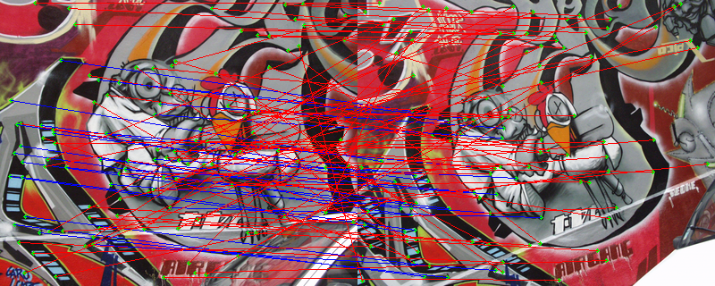

*Results of RANSAC: outliers (red) and inliers (blue) with the optimal affine transform*

Calculated affine transform matrix:

[[ 0.793 0.34 -20.152]

[ -0.27 0.915 81.827]

[ 0. 0. 1. ]]

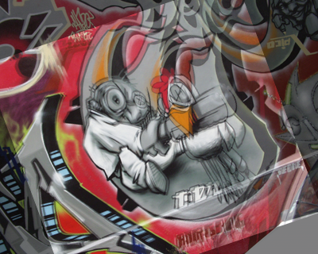

*Results of image stitching using the calculated transform*

**Discussion:** This alignment worked decently. Some points, such as the bottom left of the bug-person, are very well lined up, while the peripheral artifacts of graf1 are not as well aligned. It is likely that a projective transformation would be better, since it seems that the scaling requires another dimension.

graf1 🡪 graf3

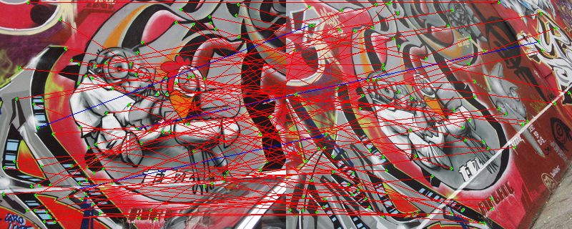

*Results of RANSAC: outliers (red) and inliers (blue) with the optimal affine transform*

Calculated affine transform matrix:

[[ 2.31000e+00 -1.10100e+00 1.06599e+02]

[ 1.53000e-01 1.66900e+00 -2.70155e+02]

[ 0.00000e+00 0.00000e+00 1.00000e+00]]

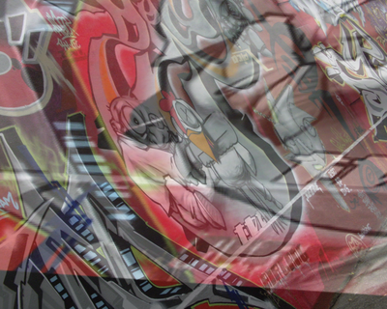

*Results of image stitching using the calculated transform*

**Discussion:** Evidently, this alignment was very poor. No parts of the image line up, and the matched features that are considered inliers after RANSAC do not even really match up. It is likely because of the geometric relationship between the two images; they are taken from very different angles, which would require a projective transformation.

**LEUVEN**

Optimized parameters:

|  |  |
| --- | --- |
| **Parameter** | **Value** |
| w_diam | 7 |
| k | 0.05 |
| s_size | 3 |
| r_thresh | 0.01 |
| nms_window | 7 |
| wsize | 9 |
| p | 0.999 |
| e | 0.5 |
| s | 3 |
| inlier_thresh | 20 |

leuven1 🡪 leuven2

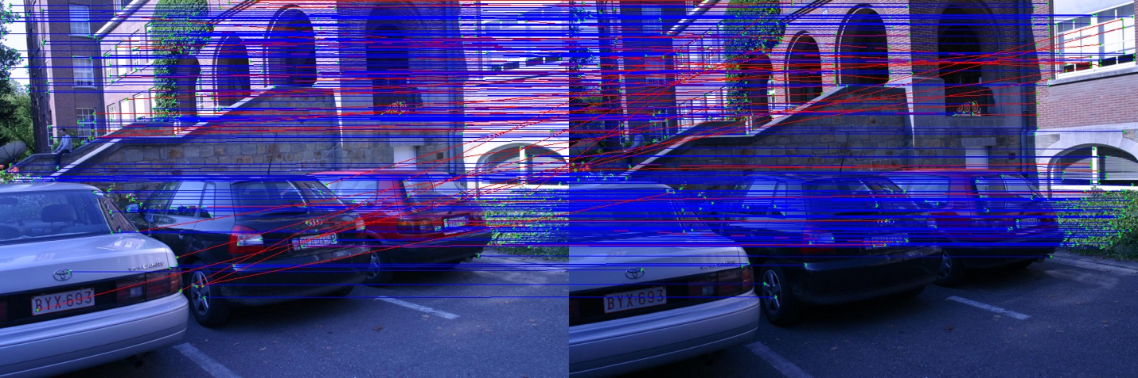

*Results of RANSAC: outliers (red) and inliers (blue) with the optimal affine transform*

Calculated affine transform matrix:

[[ 1.003 -0.006 5.147]

[ 0.008 0.993 -2.856]

[ 0. 0. 1. ]]

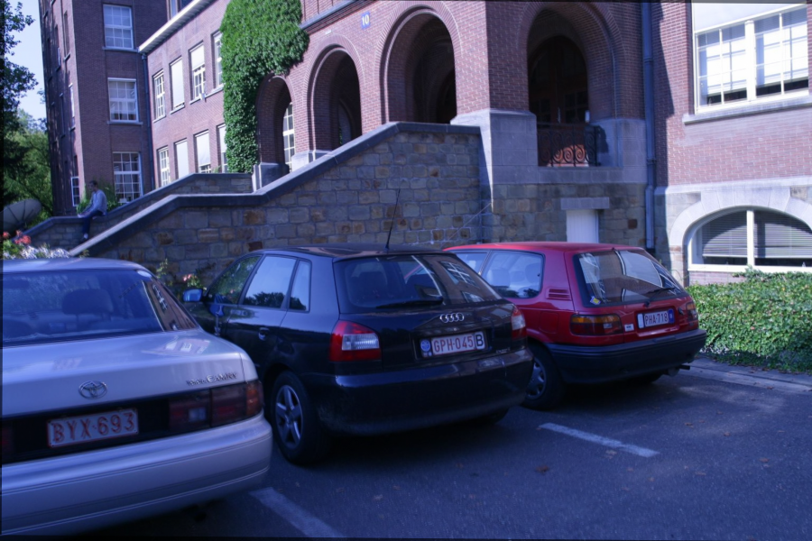

*Results of image stitching using the calculated transform*

**Discussion:** This alignment worked pretty much perfectly. There is a small amount of blurring that can be seen, but otherwise the transform is very accurate. This is corroborated by the high proportion of blue to red lines in the RANSAC results image.

leuven1 🡪 leuven3

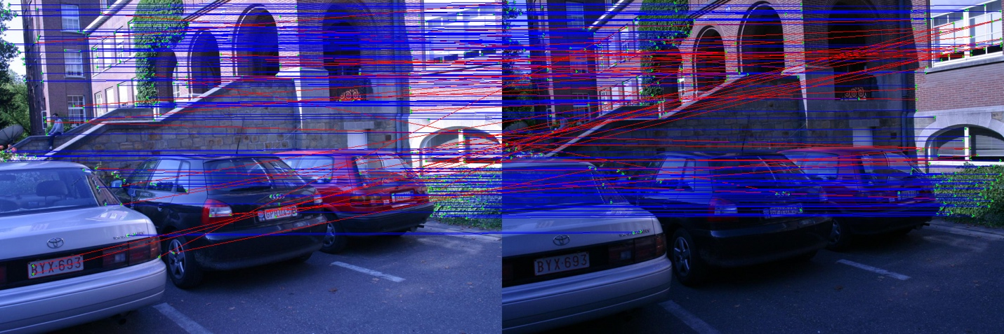

*Results of RANSAC: outliers (red) and inliers (blue) with the optimal affine transform*

Calculated affine transform matrix:

[[ 1.002e+00 3.000e-03 4.555e+00]

[ 2.000e-03 9.930e-01 -3.314e+00]

[ 0.000e+00 0.000e+00 1.000e+00]]

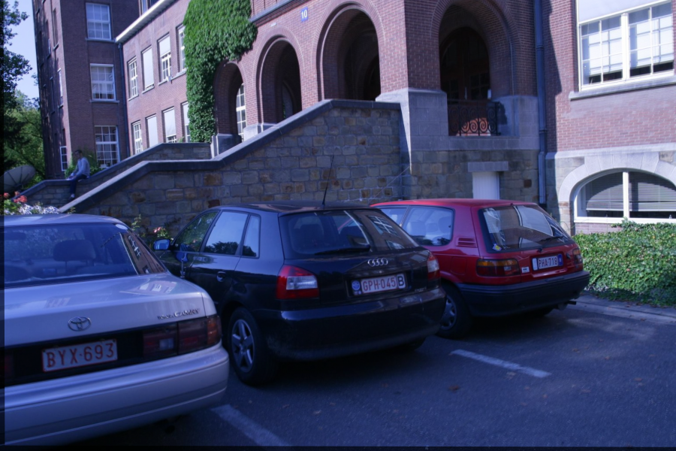

*Results of image stitching using the calculated transform*

**Discussion:** This alignment also worked pretty much perfectly. There is a small amount of blurring that can be seen, but otherwise the transform is very accurate. This is corroborated by the high proportion of blue to red lines in the RANSAC results image.

**WALL**

Optimized parameters:

|  |  |
| --- | --- |
| **Parameter** | **Value** |
| w_diam | 7 |
| k | 0.05 |
| s_size | 3 |
| r_thresh | 0.2 |
| nms_window | 15 |
| wsize | 9 |
| p | 0.999 |
| e | 0.5 |
| s | 3 |
| inlier_thresh | 50 |

wall1 🡪 wall2:

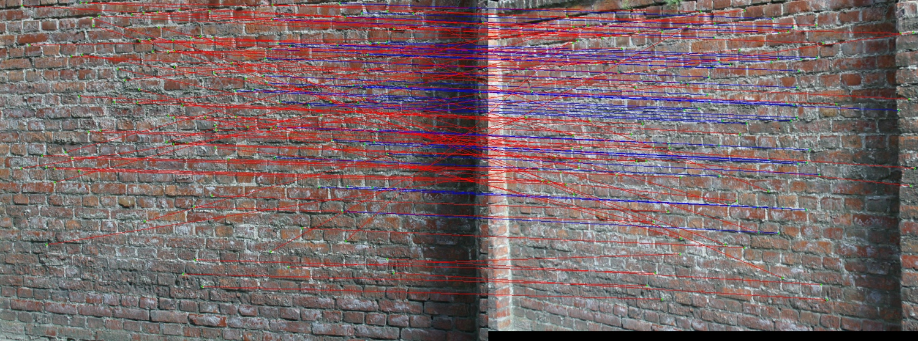

*Results of RANSAC: outliers (red) and inliers (blue) with the optimal affine transform*

Calculated affine transform:

[[ 8.8400e-01 2.4000e-02 -3.3284e+01]

[-8.0000e-03 1.0260e+00 3.9107e+01]

[ 0.0000e+00 0.0000e+00 1.0000e+00]]

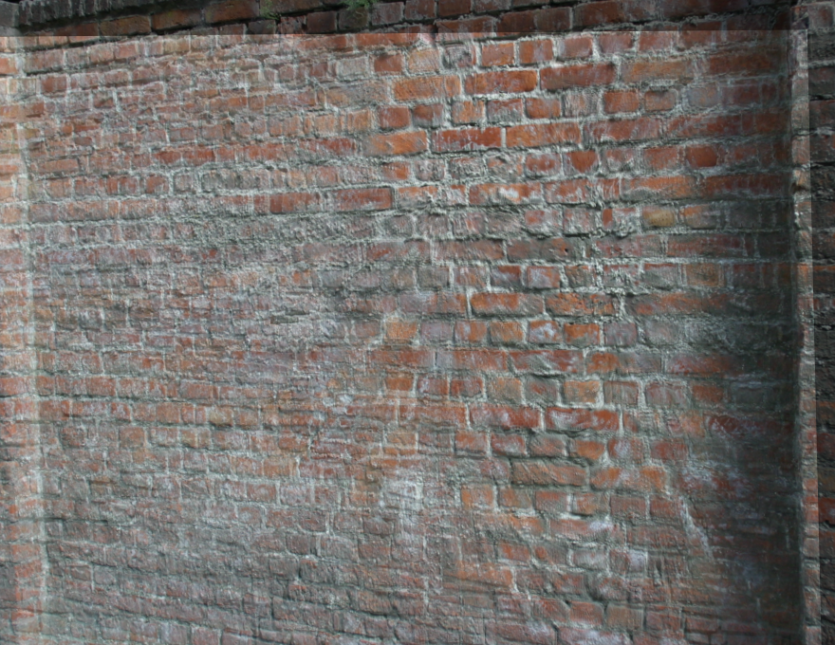

*Results of image stitching using the calculated transform*

**Discussion:** This alignment worked fairly well. Around the center-right of the image, the alignment is near perfect, but surrounding it, there is a good amount of blurring caused by discrepancies in the overlaid images. It is likely due to the difference in angles of the images, which a projective transformation would be better able to account for.

wall1 🡪 wall3

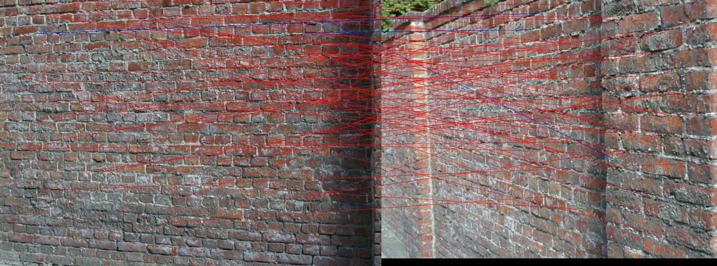

*Results of RANSAC: outliers (red) and inliers (blue) with the optimal affine transform*

Calculated affine transform matrix:

[[-4.70000e-02 -3.31300e+00 7.17799e+02]

[ 4.80000e-02 -5.29600e+00 4.95723e+02]

[ 0.00000e+00 0.00000e+00 1.00000e+00]]

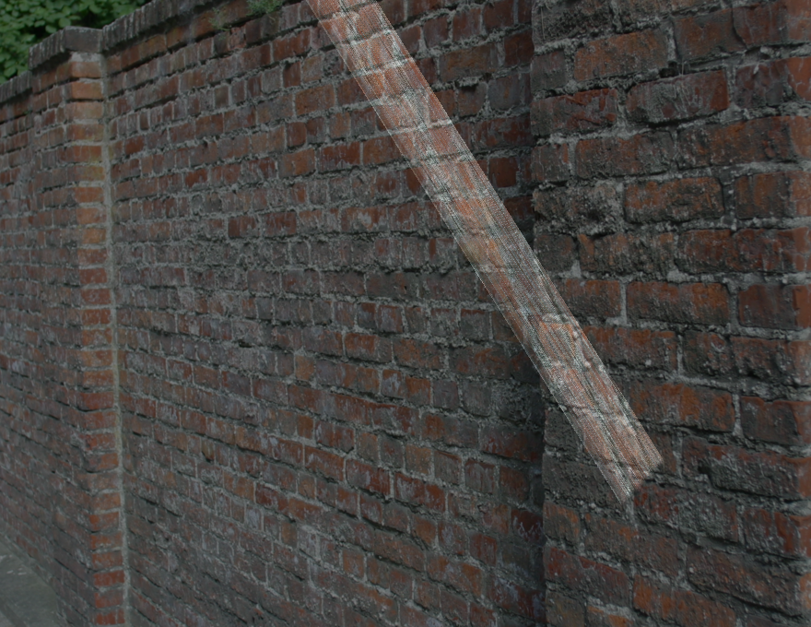

*Results of image stitching using the calculated transform*

**Discussion:** This alignment was extremely poor, with little to no correlation between the transformed image and the second image. Looking at the two images, there is a very large difference between the angle used to capture each image, resulting in a large difference in the way these appear in a 2D plane. A projective transformation is required to accurately perform an alignment of these two images.